**Session 2**

Stimulus Computer (neben der Türe):

Desktop - LESS - Session 2 - Norway Session 2

Password Recording Computer 2 (auf Schreibtisch):

polar2020

**Before participant is arriving:**

* Go in room downstairs and grab
  + a medium sized towel (for putting it around the neck of the participant)
  + The battery (always take the one in the box that layes **below** all the others; and check if a new battery is fully loaded, if so put it in the box)
  + Put a big towel on the experiment table (place the electrodes and the dummy head on it)
  + Turn on the red light

**Participant arrives:**

* Glas of water
* Measure head circumference to choose the EEG-head
* Try on the EEG-head, if it suits, then put it on the dummy head to connect the electrodes
* Put a towel around the participants neck, clip it and put the clip (for connecting the head to the cable) on the towel
* Put the EEG-head with the electrodes on the head; say that participant has to be careful with the cables now!
* Measure from nose to bump (nasion) at the back of the head (inion) -> 24 should be in the middle -> adjust
* Measure from the tip of the both ears -> 24 should be in the middle -> adjust

**During experiment:**

* bevore "Experiment" impedanz checken, if everything is greeen
* Show the participant the signal of the EEG (**no recording**):

Only in Session 2

1. tell participant that he/she should not move -> clear signal
2. Ask the participant to blink -> FP 1 and FP2
3. Ask participant to jawn

"Muscle activity" (large movements) vs brain activity/electrical activity in the brain (little movements)

Especially the face is the most important think, we encourage you not to move

Escpecially when there is a word, then down move or blink. After that you see the mouse and you can blink again.

Instructions on the screen where it is important not to move

Rs-15.eeg (first recording)

15.eeg (second recording)

**Recording:**  
Resting state (10 min - 5 min eyes open/closed, 5 min instruction), Training (45 min), Experiment (

Try not to blick when the words ar presentet, when you see the mouse while responding, you can blink

**Orange stripes on the screen (i.s.r. = impedance, signal, record) -> Press c twice**

**Save the recording as "participant number.eeg"**

**End of eeg experiment:**

* On recording Cimputer 2: Stop, "Disconnect"
* Press "c" once, that everything closes
* Turn off the light at the door

**After participant left:**

* Clean the EEG head and the electrodes
* Take the golden "LAB" stick and take the data from Stimulus Computer (1 file) and Recording Computer 2 (6 files) and upload this to OSF (therefore use your own laptop); you can remove the "Recorder" Stick from the Laptop and put the "LAB" Stick in it (but close the program before)
* Data from Stimulus Computer 1 is in Desktop -> Session 2
* Data from Recording Computer 2 is in Quick access -> Raw files
* We have for one eeg recording 3 files. In this session we have the resting state and the test recording. That is 6 files.

-> In total we have then **7 files** for session 2 (6 from eeg, 1 behavioural)

* Refill the gel

**Session 3/4**

**Preparing before the participants arrives:**

* We already know the head size -> get the head, place it on the dummy head and connect the electrodes
* Put the electrodes to the cap

**When participant arrives:**

* Bring water
* Put electrodes with cap on the head (cap should be at the eyebrows)
* Measure the fit of the cap:
  + first from nasion to inion
  + then from the one ear to the other ear - middle should be electrode number 24
  + everything should be symmetrical
* Fill in the gel
* Look if impedance is good (= green light, and look as well at the signal - if it is noisy/a lot of movements in some electrodes, check the number by clicking with the mouse over the colour/name of the electrodes - shoud be as near to 0 as possible and maximum 10, but i is 8 or sth like that, then put a bit more gel or wiggle)
* Gnd and ref should be under 2
* Smalltalk with participant
* Look that size of the table and of the chair is good

**During EEG experiment:**

* Both laptops should be charged during experiment
* White/invisible cable should be in the stimulus computer
* Press C two times when there is a notice at the screen

(when there are two orange stripes) -> read the README

* Save recordings as "participantnumber.eeg" (for example 16.eeg) and press "yes, I do want to overwrite" (because we have everything save at OSF)

**After experiment:**

* R crossed on the screen means (three things):

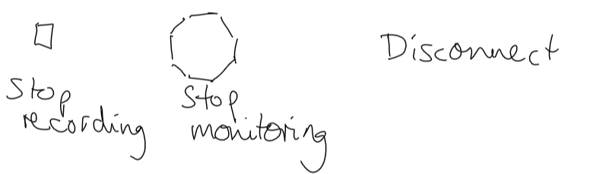

* go downstairs (with the participant)
* Participant can wash the head and therefore I give him a small towel
* Washing the cap and the electrodes (3-4 times fill the bag with warm water), then let it there for 25 min with water -> this is enough time, you don´t need the brush.
* In the mean time:
  + clean the shower
  + load the battery
  + get the new battery
  + get a medium sized towel
  + Refill the gel

* Let the electrodes downstairs to dry in a towel
* Bring the cap upstairs together with the box
* Towel that was on the participants shoulder is used for keeping the electrode cabels save from water
* The two towels (from participants shoulders and from participants washing) go to the washing mashine

* If Boot 1 ( lab downstairs is busy wit a session - therefore check calendar), then go to the kitchen in our floor to wash the cap and electrodes.. But participant can wash hair, but needs to be quiet and we can not talk in the room
* In session 3 and 4 we have 4 files to save on OSF (1 behavioural, 3 from eeg)

* **Copy data** (behavioural - from Stimulus computer; and EEG - from Recording Computer 2)**to the OSF** vith the golden "LAB" stick (see video)